Practical No. 7

Name : Danish Altaf Solkar Class : CO - B
Enrolment no. : 24111590805 Batch : 2

Aim : Configure DNS using relevant Software

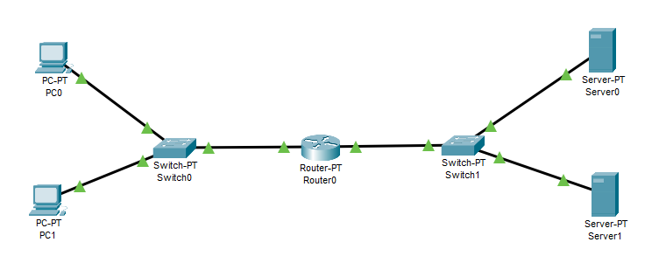

Addressing Table : -

Device | Interface | IP Address | Default Gateway
PC0 | Fa0 | 192.168.1.2 | 192.168.1.1
PC1 | Fa0 | 192.168.1.3 | 192.168.1.1
Router 0 | Fa0/0 | 192.168.1.1 | -
Router 0 | Fa1/0 | 192.168.2.1 | -
Server 0 (DNS) | Fa0 | 192.168.2.2 | 192.168.2.1
Server1  (Web Server)  arkp.com | Fa0 | 192.168.2.3 | 192.168.2.1

